# EEE3088F Group Project Assignment 2

1. Power Supply Subsystem
   1. The circuit simulations for the Design show how the Buck regulator successfully steps down the supply voltage of the circuit. There is an initial delay where the output voltage slowly increases, before the circuit reaches a stable state at 4.4 V. Upon closer inspection, you can see that the output line is sinusoidal, due to the MOSFET and inductor pair, which leads to this as the inductor charges and discharges based on the state of the MOSFET, with a rate of change that is dependant on the duty cycle of the regulator.





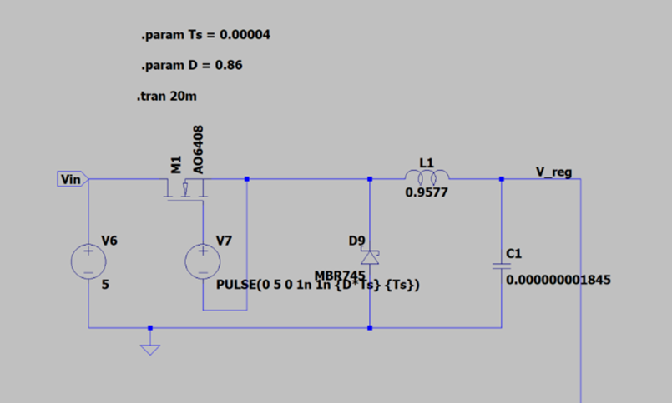

* 1. Our PiHat is powered from the 5V GPIO output pin from our Raspberry Pi (pin 2) and is grounded into pin 6. In Order to protect the PiHat and to ensure a constant voltage is supplied to the circuit, a buck switching mode regulator was used to step down the voltage from 5V to 4.4 V to ensure that the input voltage falls comfortably within the maximum voltage specifications of the LM335 temperature sensor. For this to work, there would need to be a pulse wave supplied to the MOSFET, with a frequency chosen to be 25 kHz

The component values were calculated using the below equations provided for a Buck regulator and the help of a tutor:

$$Vin=5V$$

$$Vout=4.4V$$

$$Pout=0.1 W$$

$$Iout=\frac{Pout}{Vout}=\frac{0.01}{4.3}=2.33mA$$

There is a fluctuation in I of roughly 20% in these configurations,

$$∆I=4.66×{10}^{-4} A$$

$$duty cycle is given as \frac{Vout}{Vin}=0.88$$

$$L= \frac{Vout(1-Duty cycle)}{F∆I}=\frac{4.4(1-0.88)}{25 000(4.66×{10}^{-4})}=0.0517 H$$

C was chosen to be a value of

* 1. This subsystem does meet the specifications needed for the rest of the circuit subsystems to operate optimally. As seen above, a Buck Switch Regulator was designed as part of the power supply subsystem with the purpose of regulating the 5V voltage supply rail of the Raspberry - providing the power to enable the operation of the temperature sensor PiHat as a whole. After assessment, it was deduced that the optimum operating voltage required by the TMP335 temperature sensor is 4.4V, while the RaspberryPi is only capable of supplying either a 3.3V or 5V DC voltage line to any circuit connected to it. Hence, the Buck Switch Voltage Regulator was implemented into the circuit to “buck” the 5V line from the RaspberryPi to a stable 4.4V line to the TMP335 and amplifier subsystem. Furthermore, the Buck Regulator makes use of a MOSFET and can therefore also act as a conventional switch, allowing one to halt current being supplied to the amplifier subsystem without switching off the RaspberryPi. Thus, it can be said that the power supply subsystem perfectly meets its specifications.

1. Temperature Sensor running into Operational Amplifiers

2.1) The LM355 temperature sensor was imported as an external library into LT Spice for the simulations. The data sheet supplied with the LM335 stated that the correlation between output voltage from the sensor and ambient temperature is given as: $V=\left(10×{10}^{-3}\right)T+2.73$. Where T is measured in degrees Celsius. However, after running a sweep across the temperature from 0 to 100 (depicted below where the x axis represents temperature), it was evident that the LT spice component had a slightly different relationship to the theoretical relationship specified. Calculations were done and a new relationship was defined as follows:

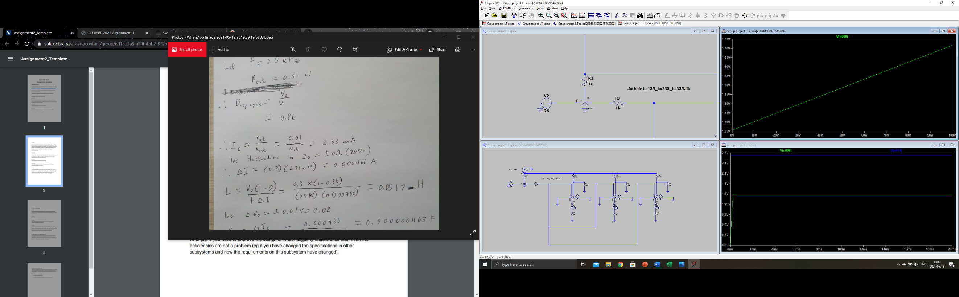

$$y=mx+c$$

Where c is the y intercept, found to be 1.257, the gradient of the graph was found by taking 2 points and calculating $\frac{rise}{run}$, the points used were (20, 1.35) and (30, 1.395). $m= \frac{1.395-1.35}{30-20}=5×{10}^{-3}$

$$∴V=5 ×{10}^{-3}T+1.2569$$

To verify this, below are the output simulations from the temperature sensor for fixed temperatures:

T = 0° C:

V should equal $$V=5 ×{10}^{-3}\left(0\right)+1.2569$$



T = 15 ° C:

V should equal

$$V=5 ×{10}^{-3}\left(15\right)+1.2569$$

$$V=1.3319$$



2.2) In the diagram below, the voltage source V2 represents ambient room temperature, as this is what allows one to simulate different temperatures.

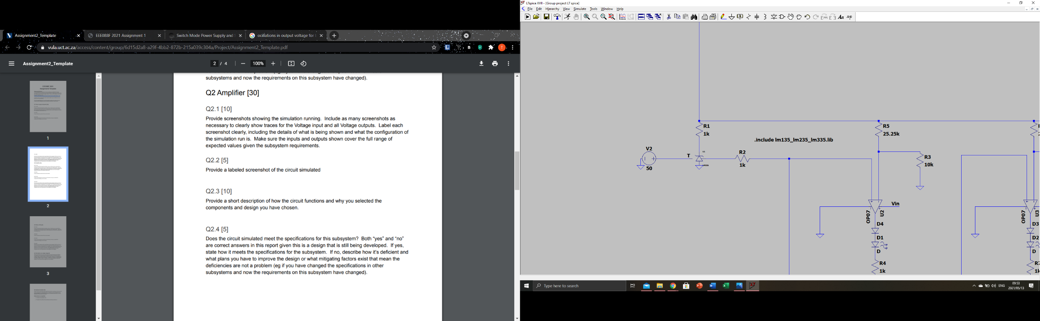

2.3) This subsystem works by taking the 4.4 Volts outputted by the voltage regulator and passing it into the component. The sensor is essentially a Zener diode that has a reverse breakdown voltage that is proportional to absolute temperature. 4.4 in the input voltage, and the output voltage is determined by the ambient temperature. As the above equation conveys, the hotter the ambient temperature, the higher the voltage output from the sensor. A resistor is placed before the sensor to limit the current flowing into the LM335 and protect the component. Originally, the initial prototype involved using the LM35 temperature sensor, however there was no LT Spice component available to simulate this. As a result, we were forced to use the LM335 as this was the only temperature sensor that met the project requirements and could be simulated.

2.4) This subsystem is made up of the TMP335 temperature sensor - the component being powered by the 4.4V line outputted by the Buck Switch Regulator, and further supplies the data needed by the comparator-LED configurations to output/display their temperature thresholds based on the voltage supplied by the TMP335. For the status LED’s to accurately display which temperature threshold is met, the TMP335 needs to output the correct voltage to the comparators based on their respective temperature thresholds. From the TMP335 data sheet, it was seen that at 0℃, the sensor would output 2.73V, increasing by 10mV/℃. However, after testing on LT Spice, a different outcome was observed. For experimental and circuit accuracy, the simulated results for Vdata were used in place of the theoretical values. This ensured that the status LEDs turned on at the correct temperatures. Thus, the specifications for this subsystem were accurately met through empirical evidence from the simulation rather than theory.

1. Status LEDS

3.1) For the status LEDs, 3 simulations are run showing the 3 states that our output diodes are in. In real life there would be potentiometers that would allow the user to set each temperature threshold, but for the sake of the simulations, the thresholds were predefined as 0 ℃, 25 ℃ and 50 ℃ . The 4th status LED is used to show that the PiHat is receiving power.

Simulation 1: temperature at 2 ℃:

Simulation 2: Temperature at 26 ℃:

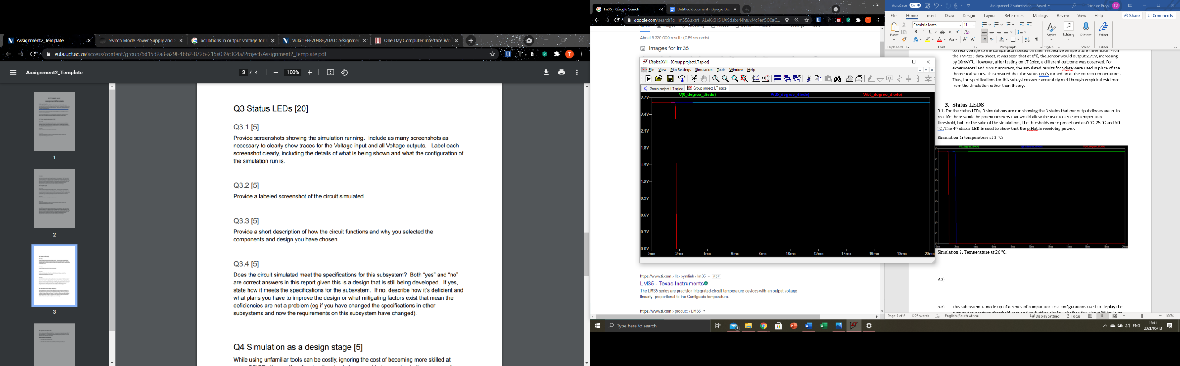

Simulation 3: 52 ℃:

The tests above show that each voltage goes high when the temperature is above the desired threshold.

3.2)

3.3) This subsystem is made up of a series of comparator-LED configurations used to display the current temperature threshold met and to further display whether the circuit/PiHat is on (receiving power from the Buck Switch Regulator) or not. Three of the configurations have their non-inverting input connected to the TMP335 data line, and their inverting input connected to the 4.4V line supplied by the Buck Switch Regulator. Each of the three inverting inputs implement a voltage divider which determines when the comparator will output high based on the voltage supplied by the TMP335.

To calculate the resistor values for each comparator circuit, we first needed to find the associated voltages for each temperature threshold. This was calculated as follows:

$$V(T)=5 ×{10}^{-3}T+1.2569$$

$$V(0)=5 ×{10}^{-3}T+1.2569$$

$$=1.256 V for 0 ℃$$

$$V(25)=5 ×{10}^{-3}T+1.2569$$

$$=1.3819 V for 25 ℃$$

$$V(50)=5 ×{10}^{-3}T+1.2569$$

$$=1.5069 V for 50 ℃$$

Using the above voltages, the resistor values for each comparator circuit can be calculated. As temperature increases, the voltage across each non-inverting input of the opamps will increase. Once above each threshold value set by the inverting inputs, the Op Amp will allow current to flow into the LED, turning it on.

Resistors for 0 ℃ LED:

$$Vthresh=Vline(\frac{R2}{R1+R2})$$

$$let R2=10kΩ$$

$$1.256=4.4(\frac{10}{R1+10})$$

$$R1=25.03kΩ$$

Resistors for 25 ℃ LED:

$$Vthresh=Vline(\frac{R2}{R1+R2})$$

$$let R2=10kΩ$$

$$1.3819=4.4(\frac{10}{R1+10})$$

$$R1=21.84 kΩ$$

Resistors for 50 ℃ LED:

$$Vthresh=Vline(\frac{R2}{R1+R2})$$

$$let R2=10kΩ$$

$$1.5069=4.4(\frac{10}{R1+10})$$

$$R1=19.19kΩ$$

3.4) The circuit provides the right output for each threshold determined; however, it is difficult to say whether the subsystem meets the desired system specifications. On its own, the subsystem works as expected and obeys the theoretical calculations described in 3.3, with each value going high at the expected threshold temperature. However, for some reason when put in conjunction with all the other subsystems present in the PiHat, the circuit did not output the desired voltages at the temperature thresholds. After multiple conversations with our tutor, it was agreed that for the purpose of the simulation, the resistor values for the voltage dividers were tinkered slightly so that we reached the desired output. All LED’s now turn on at the correct temperatures to meet the system specifications.

Question 4

During the initial stages of the design process, each subsystem of the PiHat was designed using theoretically calculated values that would at a later stage be used when designing the simulated version of the full circuit (all subsystems combined). However, complications were encountered when simulating/testing the Spice model based off the theoretical values not only calculated but the theoretical values taken straight from the datasheet of the TMP335 temperature sensor. When modelling the temperature sensor subsystem (2nd subsystem), it was observed that the temperature coefficient provided by the TMP335 datasheet did not match the simulated results. A new temperature coefficient was then determined for temperature and voltage based on the LT Spice components. This coefficient was applied to the calculations required in working out the resistor values for the op-amp comparator circuits. When individually looking at each subsystem, the desired output was observed. However, this discovery resulted in the simulated voltage divider values calculated for the comparator-LED configurations not giving the desired LED output for the set temperature thresholds when all subsystems were combined. As a result of this subsystem conundrum and changing temperature coefficient complication, when combining all subsystems, the threshold temperatures had to be changed to 0℃, 25℃ and 50℃ and the resistor voltage divider values of each comparator configuration had to be edited until the desired output was achieved. The design process of this PiHat gave the group a great deal of insight into the components that make up this circuit, as well as how LT Spice operates. However, there were various aspects of this assignment that resulted in unanswered questions that had to be solved using fiddling with results and component values rather than known calculations - although this was a direct result of the imported temperature sensor not fitting its datasheet. This assignment has been useful in conveying some of the complexities in design processes.